Lab 6 – Code and Branch Coverage Analysis
Name: Sri Vaishnavi
SRN: PES2UG24CS517
Section: I

Initial test
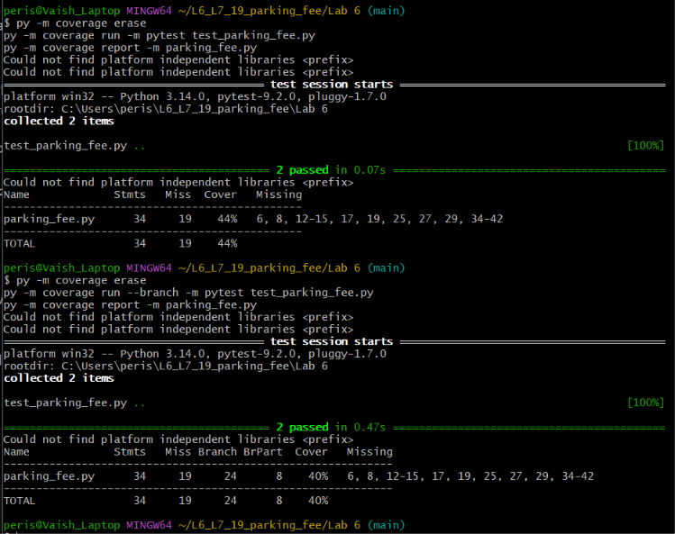
Code coverage analysis
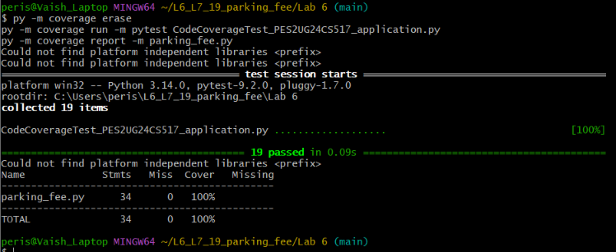
Branch coverage analysis


